Review:

1) The computer performs Boolean algebra as it does its calculations, so it is beneficial to understand it while making the computer do things.

2) A Boolean product is the result of the AND operation on two Boolean variables.

3) A Boolean sum is the result of the OR operation on two Boolean variables.

9) AND, OR, NOT, XOR

10) NAND, NOR

14) Read the problem carefully to determine the input and output values; Establish a truth table that shows the output for all possible inputs; Convert the truth table into a Boolean expression; Simplify the Boolean expression.

Exercises:

1c)

|  |  |  |  |  |
| --- | --- | --- | --- | --- |
| X | Y | X + Y | X’ + Y | (X + Y)(X’ + Y) |
| 0 | 0 | 0 | 1 | 0 |
| 0 | 1 | 1 | 1 | 1 |
| 1 | 0 | 1 | 0 | 0 |
| 1 | 1 | 1 | 1 | 1 |

9)

|  |  |  |  |  |  |
| --- | --- | --- | --- | --- | --- |
| X | Y | (X XOR Y)’ | XY | (X + Y)’ | XY + (X + Y)’ |
| 0 | 0 | 1 | 0 | 1 | 1 |
| 0 | 1 | 1 | 0 | 0 | 0 |
| 1 | 0 | 1 | 0 | 0 | 0 |
| 1 | 1 | 0 | 1 | 0 | 1 |

FALSE, they do not match.

14b) F(x,y,z) = x′yz + xz

= Z(X’Y + X) (Distributive OR)

= Z((X+X’)(X+Y)) (Distributive AND)

= Z((1)(X+Y)) (Identity AND)

= Z(X+Y) (Distributive OR)

= ZX + ZY

|  |  |  |  |  |  |
| --- | --- | --- | --- | --- | --- |
| X | Y | Z | XZ | X’YZ | X’YZ + XZ |
| 0 | 0 | 0 | 0 | 0 | 0 |
| 0 | 0 | 1 | 0 | 0 | 0 |
| 0 | 1 | 0 | 0 | 0 | 0 |
| 0 | 1 | 1 | 0 | 1 | 1 |
| 1 | 0 | 0 | 0 | 0 | 0 |
| 1 | 0 | 1 | 1 | 0 | 1 |
| 1 | 1 | 0 | 0 | 0 | 0 |
| 1 | 1 | 1 | 1 | 0 | 1 |

17b) (Solve using Boolean Algebra and a Karnaugh Map)

xy + xyz + xy′z + x′y′z

= XY + XY’Z + X’Y’Z (Absorbtion OR)

= XY + Y’Z(X) + Y’Z(X’) (Associative AND)

= XY + Y’Z(X+X’) (Distributive OR)

= XY + Y’Z(1) (Inverse OR)

= XY + Y’Z (Identity AND)

|  |  |  |  |  |  |  |  |  |
| --- | --- | --- | --- | --- | --- | --- | --- | --- |
| X | Y | Z | XY | XYZ | XY’Z | X’Y’Z | XY + XYZ + XY’Z + X’Y’Z | XY +Y’Z |
| 0 | 0 | 0 | 0 | 0 | 0 | 0 | 0 | 0 |
| 0 | 0 | 1 | 0 | 0 | 0 | 1 | 1 | 1 |
| 0 | 1 | 0 | 0 | 0 | 0 | 0 | 0 | 0 |
| 0 | 1 | 1 | 0 | 0 | 0 | 0 | 0 | 0 |
| 1 | 0 | 0 | 0 | 0 | 0 | 0 | 0 | 0 |
| 1 | 0 | 1 | 0 | 0 | 1 | 0 | 1 | 1 |
| 1 | 1 | 0 | 1 | 0 | 0 | 0 | 1 | 1 |
| 1 | 1 | 1 | 1 | 1 | 0 | 0 | 1 | 1 |

23) X’Z’ + Y’

27) A)

|  |  |  |  |  |  |
| --- | --- | --- | --- | --- | --- |
| X | Y | Z | Y(X’Z + XZ’) | X(YZ + YZ’) | Y(X’Z + XZ’) + X(YZ + YZ’) |
| 0 | 0 | 0 | 0 | 0 | 0 |
| 0 | 0 | 1 | 0 | 0 | 0 |
| 0 | 1 | 0 | 0 | 0 | 0 |
| 0 | 1 | 1 | 1 | 0 | 1 |
| 1 | 0 | 0 | 0 | 0 | 0 |
| 1 | 0 | 1 | 0 | 0 | 0 |
| 1 | 1 | 0 | 1 | 1 | 1 |
| 1 | 1 | 1 | 0 | 1 | 1 |

B)

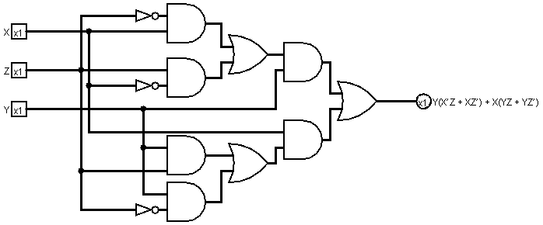

C) Y(X’Z + XZ’) + X(YZ + YZ’)

= Y(X’Z + XZ’) + X(Y(Z + Z’)) (Distributive OR)

= Y(X’Z + XZ’) + X(Y(1)) (Inverse OR)

= Y(X’Z + XZ’) + XY (Identity AND)

= YX’Z + YXZ’ + YX (Distributive OR)

= YX’Z + YX (Absorption OR)

D)

|  |  |  |  |  |  |
| --- | --- | --- | --- | --- | --- |
| X | Y | Z | YX’Z | YX | YX’Z + YX |
| 0 | 0 | 0 | 0 | 0 | 0 |
| 0 | 0 | 1 | 0 | 0 | 0 |
| 0 | 1 | 0 | 0 | 0 | 0 |
| 0 | 1 | 1 | 1 | 0 | 1 |
| 1 | 0 | 0 | 0 | 0 | 0 |
| 1 | 0 | 1 | 0 | 0 | 0 |
| 1 | 1 | 0 | 0 | 1 | 1 |
| 1 | 1 | 1 | 0 | 1 | 1 |

E)

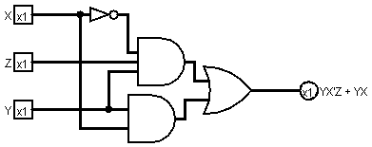

47) F = (SWB’ + BWS’ + S(WB)’ + SWB)

|  |  |  |  |  |  |  |  |
| --- | --- | --- | --- | --- | --- | --- | --- |
| S | W | B | SWB’ | BWS’ | S(WB)’ | SWB | F |
| 0 | 0 | 0 | 0 | 0 | 0 | 0 | 0 |
| 0 | 0 | 1 | 0 | 0 | 0 | 0 | 0 |
| 0 | 1 | 0 | 0 | 0 | 0 | 0 | 0 |
| 0 | 1 | 1 | 0 | 1 | 0 | 0 | 1 |
| 1 | 0 | 0 | 0 | 0 | 1 | 0 | 1 |
| 1 | 0 | 1 | 0 | 0 | 0 | 0 | 0 |
| 1 | 1 | 0 | 1 | 0 | 0 | 0 | 1 |
| 1 | 1 | 1 | 0 | 0 | 0 | 1 | 1 |

KMap Exercises:

1c) x + y’ + z

3b) F(x,y,z) = x′y′z′ + x′yz′ + xy′z′ + xyz′

|  |  |  |  |  |
| --- | --- | --- | --- | --- |
| XY  Z | 00 | 01 | 11 | 10 |
| 0 | 1 | 1 | 1 | 1 |
| 1 | 0 | 0 | 0 | 0 |

F(x,y,z) = x′y′z′ + x′yz′ + xy′z′ + xyz′

= X’Z’(Y+Y’) + XY’Z’ + XYZ’ (Idempotent)

= X’Z’(1) + XY’Z’ + XYZ’ (Inverse OR)

= X’Z’ + XY’Z’ + XYZ’ (Identity AND)

= X’Z’ + XZ’(Y+Y’) (Idempotent)

= X’Z’ + XZ’(1) (Inverse OR)

= X’Z’ + XZ’ (Identity AND)

= Z’(X+X’) (Idempotent)

= Z’(1) (Inverse OR)

= Z’ (Identity AND)

4c) y’z + wy’ + w’xy + yz’w’ + z’wx’